Gerry Gillespie
Mobile: 0407 956 458
gerry.b.gillespie@gmail.com
Gerry has been involved in the recovery of organic materials and their reuse in soils for 30 years both in Australia and overseas, including roles in New Zealand and consultancy work in Samoa, Egypt, China, Scotland, India, Wales, Ireland, UK, France, Japan, Taiwan, Canada and the US. With an emphasis on community engagement, he developed the City to Soil collection program and helped refine an inoculant-based, odour-free, no-turn compost process based on the work of M. E. Bruce and Sir Albert Howard.
He has current projects in the fields of biochar, foliar fertilisers, feral animals, worms, food waste and compost. He currently works as an Organics Consultant to local business, farmers groups and councils both in person and on-line.
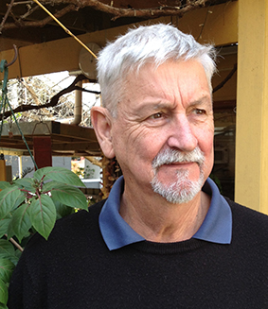
- Founding Chair – Zero Waste New Zealand Trust
- Founding Member – Zero Waste International Alliance
- Director – Zero Waste International Trust
- Member - National Sustainable Phosphorus Advisory Group (NSPAG)
- Founding Committee Member – Asian Network of Organics Recyclers
- Founding Scientific Advisory Panel Member- International Bio-char Initiative

Former Manager, SE Office, Sustainability Programs, Office of Environment and Heritage

Publications Information:
The Waste Between Our Ears – Available from Publisher Acres USA – Print version 2019
The Waste Between Our Ears – Available from Publisher Acres USA – Audio version 2023

Contributing Author:
Amazonian Dark earths; Wim Sombroek’s Vision – Springer
Positive Development; Prof Janis Birkeland - Earthscan

Manuals:
Recycling with a Focus on Food – Resource Recovery at Public Events – Manual
City to Soil – Food an organics collections – Manual
SPICE compost instruction – Manual
Bioferments Biostimulants and biofertilisers – making them on-farm

A range of videos, manuals, papers and reports is available from Gerry website free of charge: gerrygillespie.net

